Software Requirements Specification
for
SmartLib: Books Automation
Version 1.0

Prepared by
Hajare Vinay Arjun
Contents ii
Revisions ii
1 Introduction 1
1.1 Document Purpose 1
1.2 Product Scope 1
1.3 Intended Audience and Document Overview 1
1.4 Definitions, Acronyms and Abbreviations 1
1.5 Document Conventions 1
1.6 References and Acknowledgments 2
2 Overall Description 2
2.1 Product Overview 2
2.2 Product Functionality 3
2.3 Design and Implementation Constraints 3
2.4 Assumptions and Dependencies 3
3 Specific Requirements 4
3.1 External Interface Requirements 4
3.2 Functional Requirements 4
3.3 Use Case Model 5
4 Other Non-functional Requirements 6
4.1 Performance Requirements 6
4.2 Safety and Security Requirements 6
4.3 Software Quality Attributes 6
5 Other Requirements 7
Appendix A – Data Dictionary 8
Appendix B - Group Log 9

Revisions
Version | Primary Author(s) | Description of Version | Date Completed
1.0 | Hajare Vinay Arjun | Initial version. | 20/07/24

Introduction

Document Purpose
This is the Software Requirements Specification (SRS) for the SmartLib. The purpose of this document is to convey information about the application's requirements, both functional and non-functional, to the reader. This document provides –

- description of the environment in which the application is expected to operate,
- definition of the application's capabilities, and
- specification of the application's functional and nonfunctional requirements.

Product Scope
The purpose of this software development project is to create a new application called: SmartLib. SmartLib is a desktop application designed for library management, targeting small to medium-sized libraries. SmartLib is a powerful desktop application designed for seamless library management, specifically tailored for librarians to streamline their workflows. It provides a comprehensive set of features to manage books, borrowers, and library operations efficiently. SmartLib offers –
- an intuitive GUI,
- multi-user and multi-library support,
- book and borrower management,
- transaction management,
- automated reminders,
- audit support,
- authentication and security measures.

It aims to reduce the overhead for librarians and modernize the traditional library management framework.

Intended Audience and Document Overview
The intended audience for SmartLib includes librarians, library staff, and administrators who seek a user-friendly and efficient solution for managing library operations. The intended audience for this Software Requirements Specification (SRS) document includes:
- Librarians and library staff who will be using SmartLib to manage library operations
- System administrators who will be responsible for installing, configuring, and maintaining SmartLib
- Developers who will be responsible for implementing and testing SmartLib
- Project managers who will be overseeing the development and deployment of SmartLib

This SRS document provides a comprehensive overview of the requirements for SmartLib, a desktop application designed for library management. The document is organized into the following sections:
- Introduction: Provides an overview of SmartLib SRS, its purpose, and its intended audience
- Overall Description: Describes the product perspective, product functions, and product features of SmartLib
- Specific Requirements: Defines the user interfaces, hardware interfaces, software interfaces, and communications interfaces for SmartLib
- Other Non-functional Requirements: Describes the non-functional requirements for SmartLib, including book management, borrower management, transaction management, and audit support

Definitions, Acronyms and Abbreviations
Definitions:
- Library Management System (LMS): A software application that helps librarians manage the daily operations of a library, including cataloguing, circulation, and patron management.
- Integrated Library System (ILS): A comprehensive software system that integrates all aspects of library operations, including cataloguing, circulation, acquisitions, and serials management.
- MySQL: A relational database management system
- NetBeans: An integrated development environment (IDE) for Java
- Java: A programming language for developing applications for Internet and Desktop
- Swing: A framework for designing modern GUI for desktop

Acronyms and Abbreviations:
- GUI: Graphical User Interface
- JDK: Java Development Kit
- SMTP: Simple Mail Transfer Protocol
- PDF: Portable Document Format
- ISBN: International Standard Book Number

Document Conventions
In general, this document follows the IEEE formatting requirements. Use Arial font size 11, or 12 throughout the document for text. Use italics for comments. Document text should be single spaced and maintain the 1” margins found in this template. For Section and Subsection titles please follow the template.

References and Acknowledgments
1. Merlin Dorfman, Richard H. Thayer, "Standards, Guidelines, and Examples on System and software Requirements Engineering", IEEE, 1990

Overall Description

Product Overview
SmartLib is a desktop application designed for library management, specifically tailored for librarians to streamline their workflows. It provides a comprehensive set of features to manage books, borrowers, and library operations efficiently. SmartLib is a new, self-contained product that aims to replace traditional manual library management systems, providing a more efficient and automated way of managing library resources.

SmartLib is designed to cater to the needs of small to medium-sized libraries, providing a centralized system for managing books, borrowers, and library operations. The product is developed to address the limitations of traditional manual library management systems, which are often time-consuming, prone to errors, and lack automation.

The following diagram illustrates the major components of SmartLib and its interactions with the environment:

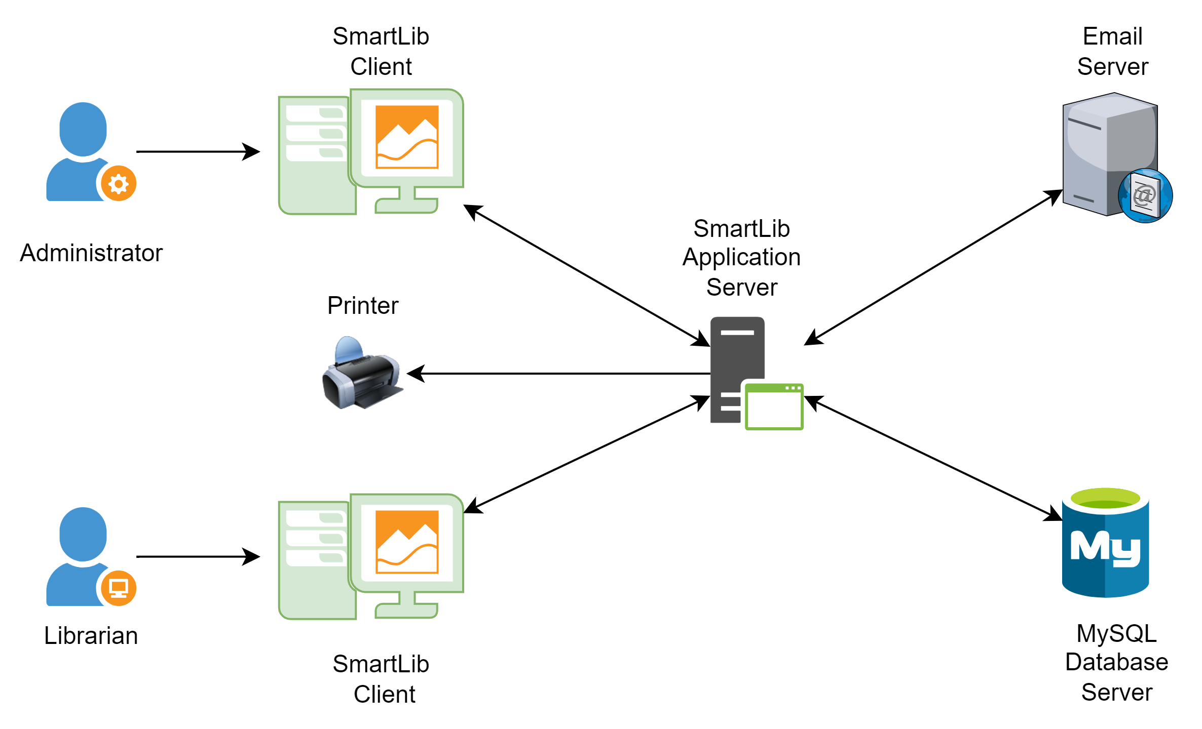

This diagram shows the major components of SmartLib, including the Librarian (end-user), SmartLib GUI (Java Swing), MySQL Database (book and borrower data storage), Email Server (SMTP), and Printer (PDF) for audit reports. The diagram illustrates how SmartLib interacts with the environment, including the librarian, database, email server, and printer.

Product Functionality
SmartLib is a desktop application designed for library management, and it must perform the following major functions:
- Book Management:
  - Add, update, and delete book records
  - Manage book inventory and availability
- Borrower Management:
  - Add, update, and delete borrower records
  - Manage borrower information and borrowing history
- Transaction Management:
  - Facilitate book issuance, return, and renewal
  - Automate date stamping, fine calculations, and notification generation
- Automated Reminders:
  - Send email reminders to patrons for due returns
- Audit Support:
  - Generate comprehensive PDF reports for audits
- Authentication and Security:
  - Implement robust authentication and input validation mechanisms
  - Ensure secure access and data protection
- Multi-User and Multi-Library Support:
  - Support multiple librarians and libraries working simultaneously
  - Enable centralized management and improved collaboration

Design and Implementation Constraints
The development of SmartLib is subject to the following constraints:

- Hardware Limitations:
- The application must be able to run on desktop computers with at least 4GB of RAM and a 2GHz processor.
- The application must be able to store and retrieve data from a MySQL database.

- Interfaces to Other Applications:
- The application must be able to integrate with email servers using SMTP protocol.
- The application must be able to generate PDF reports for audits.

- Specific Technologies, Tools, and Databases:
- The application must be developed using Java programming language.
- The application must use Java Swing for the graphical user interface.
- The application must use MySQL database for data storage and retrieval.
- The application must use javax.mail for sending automated email reminders.

- Design Conventions or Programming Standards:
- The development team must follow the COMET method for software design.
- The development team must use UML modeling language for designing and documenting the system.

- Security Considerations:
- The application must implement robust authentication and input validation mechanisms to ensure secure access and data protection.
- The application must adhere to local laws and regulations regarding data privacy and intellectual property rights.

- Parallel Operations:
- The application must be able to support multiple librarians and libraries working simultaneously.
- The application must be able to handle multiple transactions concurrently.

Assumptions and Dependencies
The development of SmartLib is based on the following assumptions and dependencies:

Assumptions:
- The development team has sufficient experience and expertise in Java programming language and MySQL database management.
- The target users (librarians and library staff) have basic computer skills and are familiar with desktop applications.
- The library's infrastructure can support the minimum hardware requirements for running SmartLib.
- The email server and SMTP protocol will be available and functioning correctly for sending automated reminders.

Dependencies:
- The project depends on the availability and stability of the MySQL database management system.
- The project depends on the compatibility of Java Swing with the target operating systems.
- The project depends on the functionality and reliability of Javax.mail for sending automated email reminders.
- The project depends on the availability of sufficient resources (time, personnel, and budget) to complete the development and testing of SmartLib.

These assumptions and dependencies may affect the requirements stated in the SRS, and the project could be impacted if they are incorrect, not shared, or change.

Specific Requirements

External Interface Requirements

User Interfaces
SmartLib provides a graphical user interface (GUI) designed using Java Swing and Nimbus, ensuring a user-friendly and intuitive experience for librarians. Users will interact with the GUI using a mouse and keyboard. The GUI will be designed to be user-friendly and intuitive, with clear and concise labeling and minimal clutter.

Hardware Interfaces
SmartLib is intended to run on desktop computers or laptops with specifications capable of running NetBeans 14 or above and JDK 16 or above. SmartLib interacts with the following hardware components:
- MySQL Database Server: Stores and retrieves book and borrower data.
- Email Server: Sends automated email reminders to patrons.
- Printer: Prints PDF reports for audits.

Each hardware component has a specific interface that allows SmartLib to interact with it. For example, the MySQL database server has a SQL interface that allows SmartLib to execute queries and retrieve data.

Software Interfaces
SmartLib utilizes the following software interfaces:
- MySQL database for data storage and retrieval.
- Javax.mail for sending automated email reminders.
- NetBeans 14 or above for development and execution.
- JDK 16 or above for Java development.
- PDF Generator: Generates PDF reports for audits.

SmartLib uses standardized interfaces to communicate with these software components, such as the SMTP protocol for email communication and the PDF generator's API for generating reports.

Communication Interfaces
Communications Interfaces: SmartLib communicates with the MySQL database to store and retrieve data. It also communicates with an SMTP server to send automated email reminders to patrons.

Functional Requirements
3.2.1 F1: Book Management
The system shall provide a book management function that allows librarians to:

- Add new book records, including title, author, ISBN, publication date, and availability status
- Update existing book records
- Delete book records
- Search for books by title, author, or ISBN
- Display book details, including title, author, ISBN, publication date, and availability status

3.2.2 F2: Borrower Management
The system shall provide a borrower management function that allows librarians to:

- Add new borrower records, including name, contact information, and borrowing history
- Update existing borrower records
- Delete borrower records
- Search for borrowers by name or contact information
- Display borrower details, including name, contact information, and borrowing history

3.2.3 F3: Transaction Management
The system shall provide a transaction management function that allows librarians to:

- Issue books to borrowers
- Return books from borrowers
- Renew books for borrowers
- Calculate fines for overdue books
- Generate notifications for overdue books

3.2.4 F4: Automated Reminders
The system shall provide an automated reminder function that sends email reminders to borrowers for:

- Overdue books
- Upcoming due dates
- Book renewals

3.2.5 F5: Audit Support
The system shall provide an audit support function that generates comprehensive PDF reports for:

- Book inventory
- Borrower statistics
- Transaction history

3.2.6 F6: Authentication and Security
The system shall provide an authentication and security function that:

- Authenticates librarians and borrowers
- Authorizes access to system functions based on user roles
- Encrypts sensitive data, such as passwords and credit card information
- Logs system activity for auditing and security purposes

3.2.7 F7: Multi-User and Multi-Library Support
The system shall provide a multi-user and multi-library support function that allows:

- Multiple librarians to access the system simultaneously
- Multiple libraries to be managed from a single system
- Centralized management and reporting for multiple libraries

3.2.8 F8: Fine Mechanism

- The system shall automatically calculate fines for overdue books based on the fine rate and overdue period.
- The system shall assign the calculated fine to the borrower's account.
- The system shall display the fine amount and overdue period to the librarian.
- The system shall allow the librarian to waive or modify the fine amount.

3.2.9 F9: Book Issuance

- The system shall allow the librarian to issue books to borrowers with automatic timestamping and return date calculation.
- The system shall check the book's availability and borrower's account status before issuing the book.
- The system shall display the book's details, including title, author, and return date, to the librarian.
- The system shall automatically generate a unique transaction ID for each book issuance.

3.2.10 F10: Book Return

- The system shall allow the librarian to return books from borrowers with automatic timestamping and fine calculation.
- The system shall check the book's issuance status and borrower's account status before returning the book.
- The system shall display the book's details, including title, author, and return date, to the librarian.
- The system shall automatically generate a unique transaction ID for each book return.

3.2.11 F11: Book Renewal

- The system shall allow the librarian to renew books for borrowers with automatic timestamping and return date calculation.
- The system shall check the book's issuance status and borrower's account status before renewing the book.
- The system shall display the book's details, including title, author, and return date, to the librarian.
- The system shall automatically generate a unique transaction ID for each book renewal.

Use Case Model
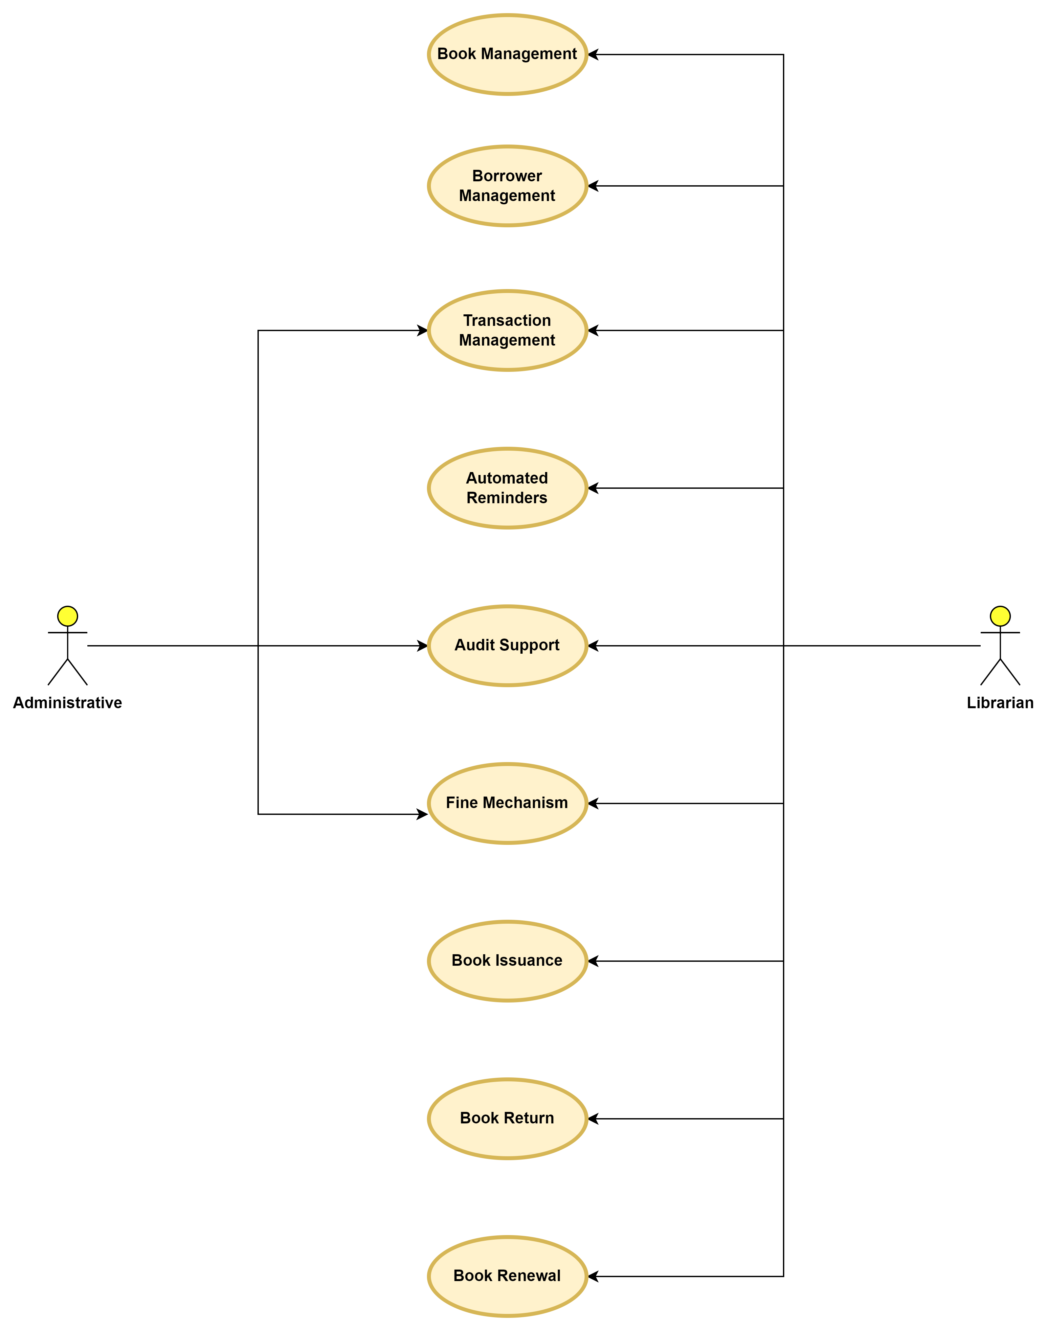

Use Case Diagram

Use Case #1: Book Management (U1)
Author – Vinay Hajare
Purpose – To manage books in the library, including adding, updating, and deleting book records.
Requirements Traceability – F1: Book Management
Priority – High
Preconditions – The librarian is logged in to the system and has the necessary permissions.
Post conditions – The book record is added, updated, or deleted successfully.
Actors – Librarian
Extends – None
Flow of Events –
Basic Flow –
  - The librarian logs in to the system.
  - The librarian selects the "Book Management" option.
  - The system displays the book management interface.
  - The librarian adds, updates, or deletes a book record.
  - The system validates the input data.
  - The system saves the changes to the book record.
Alternative Flow –
- The librarian attempts to add a duplicate book record.
- The system displays an error message indicating that the book record already exists.
Exception –
- The system encounters a database error while saving the changes.
- The librarian does not have the necessary permissions to manage books.
Includes – None
Notes/Issues – None

Use Case #2 Borrower Management (U2)
Author – Vinay Hajare

Purpose – To manage borrowers in the library, including adding, updating, and deleting borrower records.

Requirements Traceability – F2: Borrower Management

Priority – High

Preconditions – The librarian is logged in to the system and has the necessary permissions.

Postconditions – The borrower record is added, updated, or deleted successfully.

Actors – Librarian

Extends – None

Flow of Events –

Basic Flow –

- The librarian logs in to the system.
- The librarian selects the "Borrower Management" option.
- The system displays the borrower management interface.
- The librarian adds, updates, or deletes a borrower record.
- The system validates the input data.
- The system saves the changes to the borrower record.

Alternative Flow –

- The librarian attempts to add a duplicate borrower record.
- The system displays an error message indicating that the borrower record already exists.
Exceptions –

- The system encounters a database error while saving the changes.
- The librarian does not have the necessary permissions to manage borrowers.

Includes – None

Notes/Issues – None

    - Use Case #3: Transaction Management (U3)
Author – Vinay Hajare
Purpose – To manage transactions in the library, including issuing, returning, and renewing books.
Requirements Traceability – F3: Transaction Management
Priority – High
Preconditions – The librarian is logged in to the system and has the necessary permissions.
Post conditions – The transaction is processed successfully.
Actors – Librarian. Administrator
Extends – None
Flow of Events –
Basic Flow –
  - The librarian logs in to the system.
  - The librarian selects the "Transaction Management" option.
  - The system displays the transaction management interface.
  - The librarian selects the type of transaction (issue, return, renew).
  - The system validates the input data.
  - The system processes the transaction.
Alternative Flow –
  - The librarian attempts to issue a book that is already checked out.
  - The system displays an error message indicating that the book is not available.
Exception –
    - The system encounters a database error while processing the transaction.
    - The librarian does not have the necessary permissions to manage transactions.
Includes – None
Notes/Issues – None

    - Use Case #4: Automated Reminders (U4)
Author – Vinay Hajare
Purpose – To send automated reminders to borrower for overdue books.
Requirements Traceability – F4: Automated Reminders
Priority – Medium
Preconditions – The system is configured to send automated reminders.
Post conditions – The reminder is sent successfully.
Actors – Librarian, System
Extends – None
Flow of Events –
Basic Flow –
  - The system checks for overdue books.
  - The system generates a reminder for each overdue book.
  - The system sends the reminder to the borrower via email.
Alternative Flow –
  - The system encounters an error while sending the reminder.
  - The system logs the error and continues to the next reminder.
Exception –
    - The system encounters a database error while processing the transaction.
    - The borrower’s email address is invalid.
Includes – None
Notes/Issues – None

Use Case #5: Audit Support (U5)
Author – Vinay Hajare
Purpose – To generate reports for auditing and statistical purposes.
Requirements Traceability – F5: Audit Support
Priority – low
Preconditions – The system is configured to generate reports.
Post conditions – The report is generated successfully.
Actors – Librarian
Extends – None
Flow of Events –
Basic Flow –
  - The librarian logs in to the system.
  - The librarian selects the "Audit Support" option.
  - The system displays the report generation interface.
  - The librarian selects the type of report to generate.
  - The system generates the report.
Alternative Flow –
  - The system encounters an error while generating the report.
  - The system displays an error message indicating that the report cannot be generated.
Exception –
    - The system encounters a database error while retrieving data for the report.
    - The librarian does not have the necessary permissions to generate reports.
Includes – None
Notes/Issues – None

    - Use Case #6: Fine Mechanism (U6)
Author – Vinay Hajare
Purpose – To automatically calculate and assign fines to borrowers for overdue books.
Requirements Traceability – F3: Transaction Management,
Priority – High
Preconditions – The system is configured to calculate fines for overdue books.
Post conditions – The fine is calculated and assigned to the borrower successfully.
Actors – System
Extends – U3: Transaction Management
Flow of Events –
Basic Flow –
  - The system checks for overdue books.
  - The system calculates the fine based on the overdue period and fine rate.
  - The system assigns the fine to the borrower's account.
Alternative Flow –
  - The system encounters an error while calculating the fine.
  - The system logs the error and continues to the next overdue book.
Exception –
- The system encounters a database error while retrieving overdue books.
- The fine rate is not configured in the system.
Includes – U3: Transaction Management
Notes/Issues – None

    - Use Case #7: Book Issuance (U7)
Author – Vinay Hajare
Purpose – To issue books to borrowers with automatic timestamping and return date calculation.
Requirements Traceability – F3: Transaction Management,
Priority – High
Preconditions – The book is available and the borrower has a valid account.
Post conditions – The book is issued to the borrower successfully.
Actors – Librarian
Extends – U3: Transaction Management
Flow of Events –
Basic Flow –
- The librarian logs in to the system.
- The librarian selects the "Issue Book" option.
- The system displays the book issuance interface.
- The librarian selects the book and borrower.
- The system checks the book's availability and borrower's account status.
- The system issues the book to the borrower with automatic timestamping and return date calculation.
Alternative Flow –
- The book is not available.
- The system displays an error message indicating that the book is not available.
Exception –
  - The system encounters a database error while issuing the book.
  - The borrower's account is invalid or suspended.
Includes – U3: Transaction Management
Notes/Issues – None

    - Use Case #8: Book Return (U8)
Author – Vinay Hajare
Purpose – To return books from borrowers with automatic timestamping and fine calculation.
Requirements Traceability – F3: Transaction Management,
Priority – High
Preconditions – The book is issued to the borrower and the borrower has a valid account.
Post conditions – The book is returned successfully and any fines are calculated and assigned.
Actors – Librarian
Extends – U3: Transaction Management
Flow of Events –
Basic Flow –
  - The librarian logs in to the system.
  - The librarian selects the "Return Book" option.
  - The system displays the book return interface.
  - The librarian selects the book and borrower.
  - The system checks the book's issuance status and borrower's account status.
  - The system returns the book with automatic timestamping and fine calculation.
Alternative Flow –
  - The book is not issued to the borrower.
  - The system displays an error message indicating that the book is not issued to the borrower.
Exception –
  - The system encounters a database error while returning the book.
  - The borrower's account is invalid or suspended.
Includes – U3: Transaction Management, U6: Fine Mechanism
Notes/Issues – None

    - Use Case #9: Book Renewal (U9)
Author – Vinay Hajare
Purpose – To renew books for borrowers with automatic timestamping and return date calculation.
Requirements Traceability – F3: Transaction Management,
Priority – High
Preconditions – The book is issued to the borrower and the borrower has a valid account.
Post conditions – The book is renewed successfully with automatic timestamping and return date calculation.
Actors – Librarian
Extends – U3: Transaction Management
Flow of Events –
Basic Flow –
  - The librarian logs in to the system.
  - The librarian selects the "Renew Book" option.
  - The system displays the book renewal interface.
  - The librarian selects the book and borrower.
  - The system checks the book's issuance status and borrower's account status.
  - The system renews the book with automatic timestamping and return date calculation.
Alternative Flow –
  - The book is not issued to the borrower.
  - The system displays an error message indicating that the book is not issued to the borrower.
Exception –
  - The system encounters a database error while renewing the book.
  - The borrower's account is invalid or suspended.
Includes – U3: Transaction Management, U6: Fine Mechanism
Notes/Issues – None

Other Non-functional Requirements

Performance Requirements
P1: Response Time
- The system shall respond to user input within 2 seconds.
- Rationale: This performance requirement ensures that the system provides a responsive user experience, allowing librarians to efficiently manage books and borrowers.

P2: Data Retrieval
- The system shall retrieve book and borrower data within 1 second.
- Rationale: This performance requirement ensures that the system can quickly retrieve data, enabling librarians to quickly access information and make informed decisions.

P3: Transaction Processing
- The system shall process book issuance, return, and renewal transactions within 3 seconds.
- Rationale: This performance requirement ensures that the system can efficiently process transactions, minimizing wait times and enabling librarians to quickly complete tasks.

P4: Fine Calculation
- The system shall calculate fines within 1 second of a book being returned.
- Rationale: This performance requirement ensures that the system can quickly calculate fines, enabling librarians to accurately assess penalties and update borrower accounts.

P5: Report Generation
- The system shall generate reports within 5 seconds.
- Rationale: This performance requirement ensures that the system can quickly generate reports, enabling librarians to access timely and accurate information.

P6: System Availability
- The system shall be available for use 99.9% of the time, with a maximum downtime of 1 hour per month for maintenance and updates.
- Rationale: This performance requirement ensures that the system is highly available, minimizing downtime and enabling librarians to access the system when needed.

These performance requirements outline the specific performance expectations for the SmartLib system, ensuring that it provides a responsive, efficient, and reliable user experience.

Safety and Security Requirements
S1: Data Encryption
- The system shall encrypt all data transmitted between the mobile app and the server using SSL/TLS protocol.
- Rationale: This safety requirement ensures that sensitive data, such as borrower information and book details, is protected from unauthorized access during transmission.

S2: User Authentication
- The system shall require users to authenticate using a unique username and password before accessing the system.
- Rationale: This safety requirement ensures that only authorized users can access the system and perform actions.

S3: Access Control
- The system shall implement role-based access control, restricting access to certain features and data based on user roles (e.g., librarian, administrator).
- Rationale: This safety requirement ensures that users can only access features and data that are relevant to their role, reducing the risk of unauthorized actions.

S4: Data Backup and Recovery
- The system shall perform daily backups of all data and store them securely offsite.
- The system shall have a disaster recovery plan in place to ensure data can be restored in the event of a disaster.
- Rationale: This safety requirement ensures that data is protected in the event of a disaster or system failure, minimizing the risk of data loss.

S5: Server Security
- The server shall be configured with secure protocols, such as SSH, for remote access.
- The server shall have up-to-date security patches and antivirus software installed.
- Rationale: This safety requirement ensures that the server is protected from unauthorized access and malicious attacks.

S6: Compliance with Regulations
- The system shall comply with relevant regulations, such as GDPR and COPPA, regarding data privacy and security.
- Rationale: This safety requirement ensures that the system meets legal requirements for data privacy and security, minimizing the risk of legal liability.

S7: Incident Response
- The system shall have an incident response plan in place to respond to security incidents, such as data breaches or unauthorized access.
- Rationale: This safety requirement ensures that the system can quickly respond to security incidents, minimizing the impact of the incident.

These safety and security requirements outline the specific measures that must be taken to ensure the SmartLib system protects user data, prevents unauthorized access, and complies with relevant regulations.

Software Quality Attributes

Reliability
- The system shall have a mean time between failures (MTBF) of at least 500 hours.
- The system shall have a mean time to repair (MTTR) of no more than 2 hours.
- Rationale: This quality attribute ensures that the system is reliable and can operate continuously without failures, minimizing downtime and ensuring that librarians can access the system when needed.

To achieve this, we will:
- Implement redundant components and systems to ensure that the system can continue to operate in the event of a failure.
- Develop a comprehensive testing plan to identify and fix errors before deployment.
- Implement a robust error handling mechanism to detect and recover from errors.

Adaptability
- The system shall be able to adapt to changes in the library's policies and procedures within 2 weeks of notification.
- The system shall be able to integrate with new hardware and software components within 1 month of deployment.
- Rationale: This quality attribute ensures that the system can adapt to changes in the library's operations and can integrate with new components, minimizing the impact of changes on the system.

To achieve this, we will:
- Design the system using modular architecture to allow for easy modification and integration of new components.
- Implement a flexible data model that can accommodate changes in the library's policies and procedures.
- Develop a comprehensive testing plan to ensure that the system can adapt to changes without affecting its performance.

Usability
- The system shall have a user interface that is intuitive and easy to use, with a minimum of 90% of users able to complete tasks without assistance.
- The system shall provide clear and concise error messages and feedback to users.
- Rationale: This quality attribute ensures that the system is easy to use and provides a positive user experience, minimizing the need for training and support.

To achieve this, we will:
- Conduct user research and testing to identify user needs and preferences.
- Design the user interface using principles of human-centered design and usability.
- Implement a comprehensive help system and user documentation to support users.

Maintainability
- The system shall have a maintainability index of at least 80%, as measured by the Maintainability Index metric.
- The system shall have a mean time to resolve (MTTR) of no more than 4 hours for maintenance tasks.
- Rationale: This quality attribute ensures that the system is easy to maintain and update, minimizing the time and resources required for maintenance.

To achieve this, we will:
- Design the system using modular architecture to allow for easy modification and maintenance.
- Implement a comprehensive testing plan to ensure that changes do not affect the system's performance.
- Develop a maintenance plan that includes regular updates and patches to ensure that the system remains stable and secure.

Other Requirements

Database Requirements
- The system shall use a relational database management system (RDBMS) to store data.
- The database shall be designed to support a minimum of 10,000 users and 50,000 books.
- The database shall have a data redundancy mechanism to ensure data integrity and availability.

Internationalization Requirements
- The system shall support multiple languages, including English and regional language.
- The system shall be able to handle different date and time formats, as well as currency and numeric formats.
- The system shall be able to support different character sets and encoding schemes.

Legal Requirements
- The system shall comply with all applicable laws and regulations, including copyright laws and data privacy laws.
- The system shall provide a mechanism for obtaining user consent for data collection and use.
- The system shall provide a mechanism for users to request access to their data and to request that their data be deleted.

Reuse Objectives
- The system shall be designed to allow for reuse of components and code in future projects.
- The system shall use open standards and protocols to facilitate reuse and integration with other systems.
- The system shall have a modular architecture to allow for easy modification and extension.

Environmental Requirements
- The system shall be designed to operate in a variety of environmental conditions, including temperature ranges from 10°C to 30°C and humidity levels from 20% to 80%.
- The system shall be designed to operate in a variety of lighting conditions, including low light and high light environments.
- The system shall be designed to be energy efficient and to minimize its environmental impact.

Training and Support Requirements
- The system shall provide online help and documentation to support user training and troubleshooting.
- The system shall provide a mechanism for users to request support and to report issues.
- The system shall have a comprehensive user manual and training program to support user adoption and proficiency.

5.7 Documentation Requirements
- The system shall have comprehensive documentation, including user manuals, technical guides, and release notes.
- The system shall have a documentation plan that outlines the documentation requirements and timelines.
- The system shall have a documentation review and approval process to ensure that documentation is accurate and complete.

Appendix A – Data Dictionary
Constants –

Constant | Description | Value
MAX_BOOKS | Maximum number of books in the library | 50,000
MAX_USERS | Maximum number of users in the system | 10,000
FINE_RATE | Fine rate for overdue books | ₹20 per day
RETURN_WINDOW | Time window for returning books | 1 weeks

State Variables –

State Variable | Description | Possible States
Book Status | Status of a book (available, checked out, overdue) | Available, Checked Out, Overdue
User Status | Status of a user (active, inactive) | Active, Inactive
Transaction Status | Status of a transaction (pending, completed, cancelled) | Pending, Completed, Cancelled

Inputs –

Input | Description | Format
User ID | Unique identifier for a user | Integer
Book ID | Unique identifier for a book | Integer
Check Out Date | Date a book is checked out | Date (YYYY-MM-DD)
Return Date | Date a book is returned | Date (YYYY-MM-DD)
Fine Amount | Amount of fine owed by a user | Decimal

Outputs –

Output | Description | Format
Book Details | Details of a book (title, author, ISBN) | String
User Details | Details of a user (name, email, phone number) | String
Transaction History | History of transactions for a user | String
Fine Notice | Notice of fine owed by a user | String

Operations –

Operation | Description | Requirements
Check Out Book | Check out a book to a user | F1: Book Management
Return Book | Return a book from a user | F2: Book Management
Calculate Fine | Calculate fine owed by a user | F3: Fine Mechanism
Generate Report | Generate a report of transactions | F4: Reporting

Requirements –

Requirement | Description
F1: Book Management | The system shall allow librarians to manage books, including adding, updating, and deleting book records.
F2: Borrower Management | The system shall allow librarians to manage borrowers, including adding, updating, and deleting borrower records.
F3: Fine Mechanism | The system shall automatically calculate fines for overdue books and assign them to borrowers.
F4: Reporting | The system shall generate reports of transactions, including check outs, returns, and fines.

Appendix B - Group Log
Meeting 1: Introduction and Brainstorming
- Date: July 15, 2024
- Attendees: Vinay Hajare
- Agenda: Introduce team members, discuss project goals and objectives, brainstorm ideas for the SmartLib system
- Minutes:
  - Discussed project goals and objectives
  - Brainstormed ideas for the SmartLib system, including features and functionalities
  - Assigned tasks to team members, including research and documentation responsibilities

Meeting 2: Research and Requirements Gathering
- Date: July 17, 2024
- Attendees: Vinay Hajare
- Agenda: Research and gather requirements for the SmartLib system, including functional and non-functional requirements
- Minutes:
  - Researched existing library management systems and identified key features and functionalities
  - Gathered requirements from stakeholders, including librarians and library patrons
  - Identified functional and non-functional requirements for the SmartLib system

Meeting 3: System Design
- Date: July 19, 2024
- Attendees: Vinay Hajare
- Agenda: Design the SmartLib system, including the user interface, system architecture, and database design
- Minutes:
  - Designed the user interface for the SmartLib system, including the layout and navigation
  - Designed the system architecture, including the components and interactions
  - Designed the database schema, including the tables and relationships

Meeting 4: Documentation and Testing
- Date: July 20, 2024
- Attendees: Vinay Hajare
- Agenda: Document the SmartLib system, including the system design and requirements, and plan for testing and validation
- Minutes:
  - Documented the SmartLib system, including the system design and requirements
  - Planned for testing and validation, including the development of test cases and scenarios

Group Activities
- Research and documentation: Each team member was responsible for researching and documenting specific aspects of the SmartLib system, including functional and non-functional requirements, system design, and testing and validation.
- Brainstorming and idea generation: The team held regular brainstorming sessions to generate ideas and discuss the project goals and objectives.
- Collaboration and communication: The team used collaboration tools, such as Notion to communicate and collaborate on the project.
Other Relevant Information
- The team worked a total of ___ hours on the project, with each team member contributing an average of __ hours.
- The team used a variety of resources, including textbooks, online tutorials, and industry reports, to research and gather information for the project.
- The team encountered several challenges during the project, including conflicting opinions and ideas, and difficulty in gathering requirements from stakeholders. However, the team was able to overcome these challenges through open communication and collaboration.

